St Mary’s Charlbury, Oxfordshire
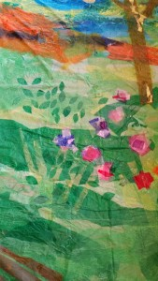
Mother’s Day Celebration 2016 integrating Messy Church involved children and families participating in a carousel of creative activities as well as a family service integrating shared creativity as a n act of worship into the church service. Parable Garden team members demonstrated the technique and jointly worked with children and young people on an initial tissue collage banner on the theme of 'All Things Bright and Beautiful' chosen by the church, the previous week prior to the service.
With leaders and children's skills and confidence built in working with the theme and media, they successfully encouraged members of the congregation and visitors to join in the creativity during the service. With leaders and children's skills and confidence built in working with the theme and media, they successfully encouraged members of the congregation and visitors to join in the creativity during the service.
Rogation Celebration 2016 the focus was on the beauty of God's earth. Psalm 84 was taken as the starting point to Messy church family activities which offered opportunities to make mosaic decorated toad dwellings from flower pots, painted bird feeders, and edible rings, linked to the churchyard conservation project. Collaborative creativity focussed on creating an altar cloth with the tree of life. People of all ages were invited to place a fabric bird roosting, nesting, flying or feeding to represent themselves and relationship with God inspired by reflection on Psalm 84.
How lovely is your dwelling place, Lord Almighty! ² My soul yearns, even faints, for the courts of the Lord; my heart and my flesh cry out for the living God. ³ Even the sparrow has found a home, and the swallow a nest for herself, where she may have her young—a place near your altar, Lord Almighty, my King and my God. ⁴ Blessed are those who dwell in your house; they are ever praising you. Psalm 84.1-4

